**Plant Disease Detection and Pest Identification**

1st Vansh Takrani 2nd Komal Chhutlani 3rd Gayatri Talreja

*Computer Department Computer Department Computer Department*

*Vivekanand Education Society* *Vivekanand Education Society* *Vivekanand Education Society*

*Institute of technology Institute of technology Institute of technology*

*Mumbai,India Mumbai,India Mumbai,India*

[2020.vansh.takrani@ves.ac.in](mailto:2020.vansh.takrani@ves.ac.in) [2020.komal.chhutlani@ves.ac.in](mailto:2020.komal.chhutlani@ves.ac.in) [2020.gayatri.talreja@ves.ac.in](mailto:2020.gayatri.talreja@ves.ac.in)

4th Nishchay Rajpal 5th Pallavi Saindane

*Computer Department Computer Department*

*Vivekanand Education Society*  *Vivekanand Education Society*

*Institute of technology Institute of technology*

*Mumbai,India Mumbai,India*

[2020.nischay.rajpal@ves.ac.in](mailto:2020.nischay.rajpal@ves.ac.in) [pallavi.saindane@ves.ac.in](mailto:pallavi.saindane@ves.ac.in)

***Abstract- Plant diseases and pests are significant factors that influence both the yield and quality of plants, presenting challenges to modern agriculture and global food security. In response to these challenges, integrated technologies have been developed for the timely detection of plant diseases, accurate identification of pests, and recommendation of suitable pesticides. This paper focuses on advancements in these areas, particularly in three crucial crops: tomato,potato, and pepper.Recognizing the importance of combating diseases and pests, the agricultural sector emphasizes the need for prompt and precise identification to minimize productivity and quantity losses in agricultural produce. In this paper,various methodologies, including image processing and machine learning techniques, are utilized for plant disease detection and pest identification. The goal is to differentiate between healthy plants and those affected by diseases by analyzing their morphology through image-based classification. Similarly, the paper also addresses the challenge of pest identification, employing similar techniques to differentiate pests from plants. Furthermore, the paper incorporates a recommendation system for pesticides based on the identified diseases and pests. By leveraging machine learning algorithms, suitable pesticides are recommended to control the spread of diseases and manage pest infestations effectively.***

***Keywords-Machine Learning, Deep Learning, Recommendation systems,Image processing.***

**I. INTRODUCTION**

In plants, signs of disease typically manifest on leaves, fruits, buds, and young branches. This scenario leads to plant wastage or damage thereby causing economic ,social , and ecological repercussions. Moreover, these ailments frequently lead to the propagation of new infections and the spread of the disease, particularly in fluctuating seasonal environments. Recognizing the potential decline in food production and the consequent jeopardy to food security, it becomes imperative to identify diseases early and implement necessary precautions before they disseminate to other plants. Similarly, pests also pose a significant menace to agriculture. The invasion of crops by pests, often unnoticed until it's too late, results in the destruction of crops or plant parts, leading to a further decline in food production. This, coupled with the scarcity of knowledge about pest management or control in various less developed countries, exacerbates the global challenge of ensuring a stable food supply.In this study, we have focused on the three plants: *tomato, potato, pepper* as these three plants are widely used and cultivated in India for various reasons, including their importance in the country's cuisine, versatility, adaptability to diverse climates, and nutritional value.The pests, along with diseases, can lead to diminished food production due to toxic pathogens, poor disease control, and drastic climate changes. Traditional methods of disease and pest detection, typically relying on manual inspection, are not only time-consuming but also prone to errors, emphasizing the pressing need for more advanced and efficient solutions. As technology continues to advance, there is a growing interest in leveraging machine learning techniques not only for the early and accurate diagnosis of plant diseases but also for the identification of pests. This technological integration holds the potential to revolutionize the way we approach and manage these challenges, offering a more comprehensive solution to ensure the resilience and sustainability of global agriculture.

The structure of the paper is as follows: Section II provides a review of relevant literature in the realm of plant disease detection. Section III elaborates on the proposed system. Section IV details the dataset utilized for the system. Section V delineates the methodology employed for plant disease detection and pest identification, emphasizing the techniques and approaches utilized. Section VI offers a summary of the experimental results. Finally, Section VII concludes the paper.

**II. LITERATURE SURVEY**

**In [1]**, Liu, Gao, and Zhang propose a modified light-weight CNN for crop disease recognition. Their model, incorporating multi-scale convolution kernels and a coordinate attention mechanism in SqueezeNext, achieves a 91.94% recognition accuracy on the AI Challenger 2018 plant disease dataset. The modifications focus on effectively extracting features from subtle leaf lesions, demonstrating a 3.02% improvement over the original SqueezeNext. Comparative experiments with ResNet50, Xception, and MobileNetV2 confirm the proposed model's balanced performance and efficiency in fine-grained crop disease classification.

**In [2]**, Gupta, Chopade, Jain, and Bhonde introduce "Farmer's Assistant," an innovative machine learning-driven application designed to address agricultural challenges. The application provides various features tailored to meet the needs of farmers, including crop recommendations utilizing the Random Forest algorithm,crop disease detection utilizing the EfficientNet model on leaf images. The user-friendly web interface simplifies access to these functionalities, thereby enhancing user experience. Notably, the integration of interpretability techniques, particularly LIME, aids in elucidating disease detection model predictions, facilitating a deeper comprehension and potential enhancement of datasets and models.

**In[3]**, Li, Zhang, and Wang offer an extensive examination of plant disease detection and classification utilizing deep learning techniques. The review underscores the benefits of deep learning, such as automatic learning and feature extraction, in tackling agricultural plant protection challenges. It delineates recent advancements, emerging trends, and existing challenges in the domain, accentuating deep learning's potential to enhance research efficiency and accelerate technological transformations in plant disease identification. The review advocates for the accumulation of large datasets with significant variability, adoption of data augmentation techniques, utilization of transfer learning, and visualization of CNN activation maps to bolster classification accuracy, achieving results of up to 94%.

**In[4],**Kasinathan, Singaraju, and Uyyala investigate insect classification and detection in field crops utilizing contemporary machine learning methodologies. The research tackles the issue of crop insect detection, introducing a pest detection algorithm that attains a notable classification rate of 91.5% and 90% for nine and 24 insect classes, respectively, leveraging the CNN model. The devised algorithm exhibits proficient detection capabilities, diminishing computation time and exhibiting substantial enhancements in classification accuracy when compared to prevailing algorithms. These results advance early-stage crop insect identification, consequently augmenting crop yield and quality in agriculture.

**In[5],**Jajoo, Jain, and Jangir offer a case study on machine learning methodologies for plant disease identification, stressing the pivotal importance of promptly detecting and recognizing crop diseases to ensure food supply security and mitigate production losses. The study concentrates on the implementation of deep learning techniques, providing an exhaustive evaluation of the current landscape in plant disease identification. The literature review accentuates diverse machine learning-driven endeavors for detecting leaf diseases and identifies principal challenges, including real-time data utilization, automated background elimination, and the incorporation of mobile devices for CNN training and testing encompassing multiple parameters. The analysis underscores noteworthy progress in leveraging convolutional neural networks (CNN) for predicting plant diseases, with emerging architectures contributing significantly to the field's advancement.

**In[6],**Kumar, Sarkar, and Pradhan present a paper addressing critical challenges in agriculture, specifically erroneous crop selection and pest-related losses. Farmers often lack knowledge about crop requirements, leading to distress both mentally and financially. The paper proposes a Recommendation System as a solution, predicting the best-suited crop for farmers, detecting potential pests, and providing pest control recommendations. The study employs SVM classification, Decision Tree, and Logistic Regression algorithms, with SVM classification demonstrating superior accuracy compared to other methods. This approach holds promise in assisting farmers, offering valuable insights to make informed decisions and mitigate losses arising from suboptimal crop choices and pest damage.

**In[7],** Satish, Venkata Gopi, Naga Sai, Chandra Mouli, and Naga Santhoshi explore the transformative potential of smart farming, utilizing image processing and machine learning. The paper emphasizes real-time crop monitoring and accurate predictions of yields, disease identification, and optimal fertilizer use. The achieved 0.9901 accuracy in identifying the best crop underscores the efficacy of this approach. Smart farming empowers farmers with timely data, revolutionizing agriculture by improving yields and reducing costs. Key areas covered include crop recommendation, disease identification, and overall cost reduction.

**III.PROPOSED SYSTEM**

The proposed system for "Plant Disease detection and Pest Identification" involves the development of an intelligent and automated system that utilizes machine learning techniques to accurately detect, classify, and diagnose plant diseases and pest infestations in crops.The proposed system enables farmers to engage with the system effortlessly through a user-friendly interface. This interface facilitates the entry of parameter values by the farmer. Subsequently, these inputted parameter values are transmitted to the developed machine learning model. The resulting output is then displayed on the website for the farmer's convenience.The website will not only deliver real-time results for disease and pest identification but will also provide users with pesticides that are essential to protect crops from pests and diseases, and to increase yield and quality. The multilingual user-friendly interface will cater to a diverse audience, from experienced farmers to individuals with limited agricultural knowledge, ensuring accessibility for users of various language backgrounds. Figure 4.1 shows the Process Flow Diagram.

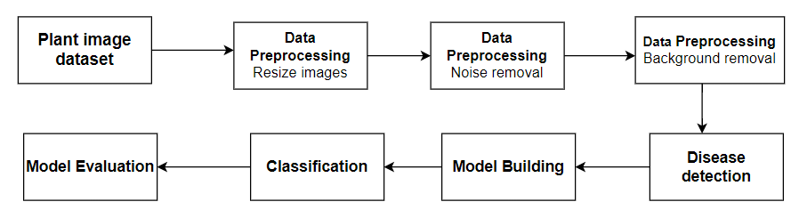

**Fig. 3.1 Block Diagram for plant disease detection**

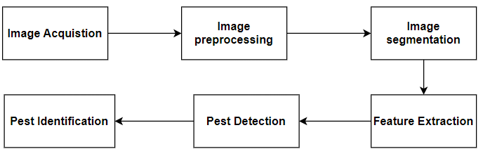

**Fig. 3.2 Block Diagram for the pest detection**

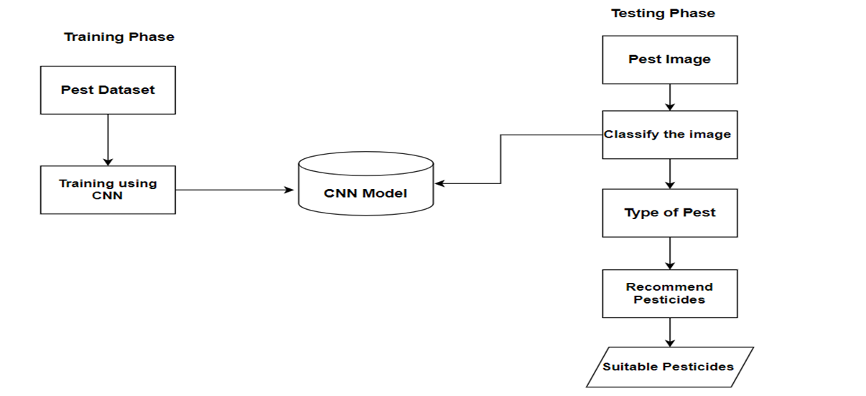

**Fig. 3.3 Block Diagram for the pesticides recommendation**

**IV. DATA SET**

**Table 1.Dataset used for plant disease detection**

| **Class No.** | **Class Name** | **No. of images** |
| --- | --- | --- |
| **1** | Pepper Bell Bacterial Spot | 841 |
| **2** | ​​Pepper Bell Healthy | 1281 |
| **3** | Potato Early Blight | 841 |
| **4** | Potato Late Blight | 841 |
| **5** | Potato Healthy | 135 |
| **6** | Tomato Bacterial Spot | 1974 |
| **7** | Tomato Leaf Mold | 838 |
| **8** | Tomato Two Spotted Spider Mite | 1516 |
| **9** | Tomato TargetSpot | 1256 |
| **10** | Tomato YellowLeaf Curl Virus | 3055 |
| **11** | Tomato Healthy | 1440 |

**Table 2.Dataset used for pest identification.**

| **Class No.** | **Class Name** | **No.of images** |
| --- | --- | --- |
| **1** | Pepper Flea Beetle | 400 |
| **2** | Pepper Thrips | 402 |
| **3** | Potato Black Cutworm | 250 |
| **4** | Potato Silverleaf Whitefly | 421 |
| **5** | Tomato Beet Armyworm | 479 |
| **6** | Tomato Red Spider Mite | 519 |

**V.METHODOLOGY**

The methodology for plant disease detection and pest identification typically involves several key steps to ensure accurate and efficient outcomes. These steps are crucial in leveraging advanced technologies such as machine learning and deep learning for agricultural applications.

The following methodology outlines the process for our project:

1.*Data Collection*:- Collected a varied dataset of images encompassing healthy plants, plants impacted by diseases, and images depicting pests.Data can be sourced from repositories like the PlantVillage Dataset, agricultural research institutions, or field surveys.

2.*Data Preprocessing*:- Clean and preprocess the collected images to enhance the quality of input data for analysis. Techniques such as resizing images to ensure uniformity, noise reduction to improve image quality, and background segmentation to isolate plant parts or pests from the background can be employed.

3.*Feature Extraction*:-Utilize deep learning techniques, particularly Convolutional Neural Networks (CNNs), for feature extraction.CNNs automatically learn lower-level features during training, aiding in the detection of patterns and characteristics relevant to plant diseases and pests.

4.*Model Selection and Training:*- Choose appropriate models such as CNNs for their effectiveness in image analysis tasks. - Train the selected model on labeled data to learn patterns associated with plant diseases and pests. - Evaluate the model's performance using validation or testing data to ensure its accuracy and generalization capabilities.

5. *Model Evaluation*:- Utilize the trained model to make predictions on novel, unseen data for plant disease detection and pest identification. Analyze the model's predictions to gain insights into disease patterns, pest presence, and potential recommendations for pests.

6. *Pesticides Recommendation:*- Based on the identified pests, suitable pesticides are recommended to protect crops from pests.

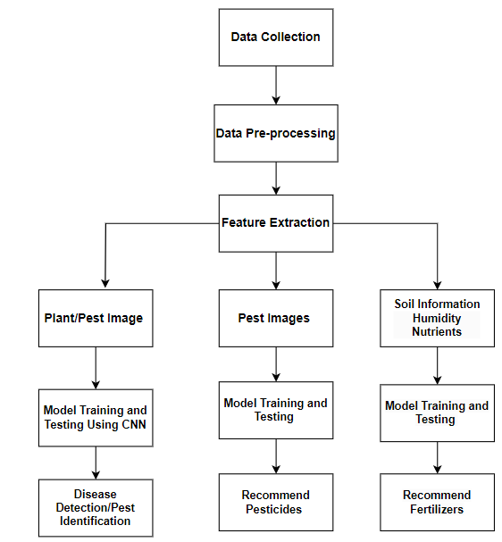

**Fig. 4.1 Flow Diagram.**

**VI.RESULT AND DISCUSSION**

We created a user interface where users can upload any image of a plant. By uploading a particular image a user can get the information about a plant such as healthy or unhealthy and can get the disease name if the plant is unhealthy and By uploading pest image information will be displayed about pest name and belong to which plant and gets the suitable recommendations to protect plants from insects and diseases such as pesticides or remedies . The data used is gathered from plantVillage dataset that includes three plants: potato, tomato, pepper. Here are the images of the three plants in Figure 6.1.

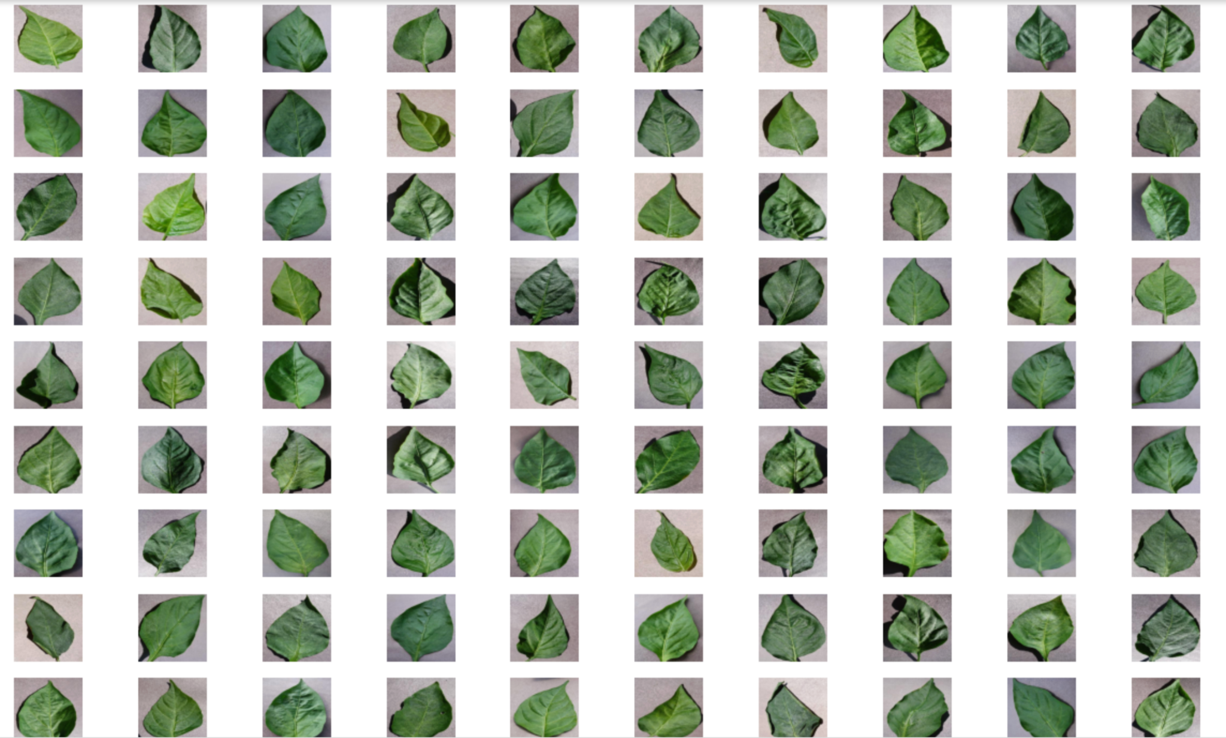

**Figure 6.1 Resized images**

In the first step of preprocessing ,images are resized so as to make them of equal size.

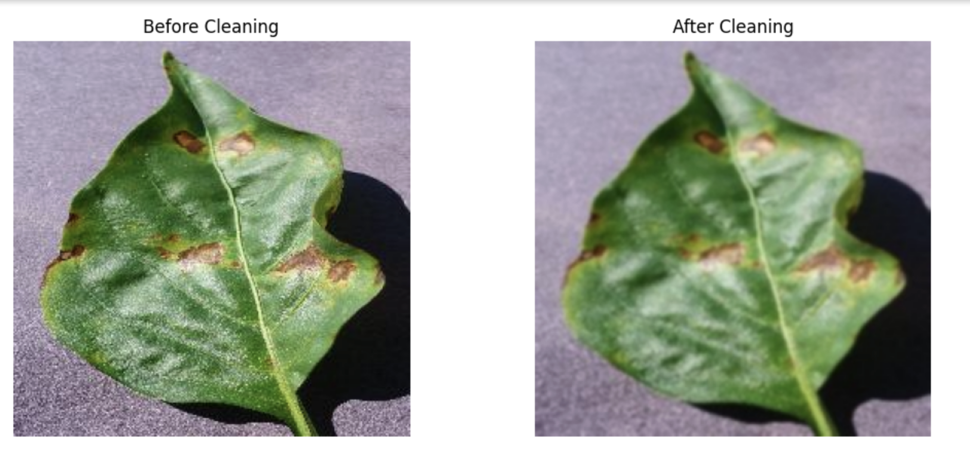

**Fig 6.2 Removing noise**

In the second stage of preprocessing, Gaussian blur is employed to eliminate noise from the image.

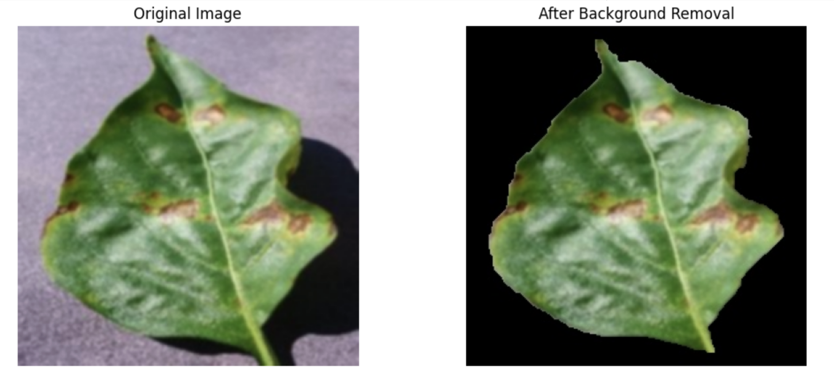

**Fig 6.3 Background removal**

In the third step of preprocessing,the background is removed to get the proper leaf image.

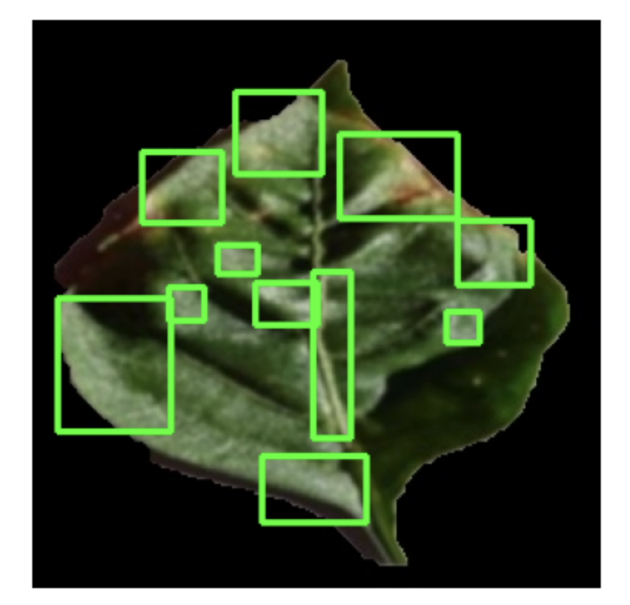

**Fig 6.4 Disease detection**

In this object detection step lesions,spots are detected on the leaf.

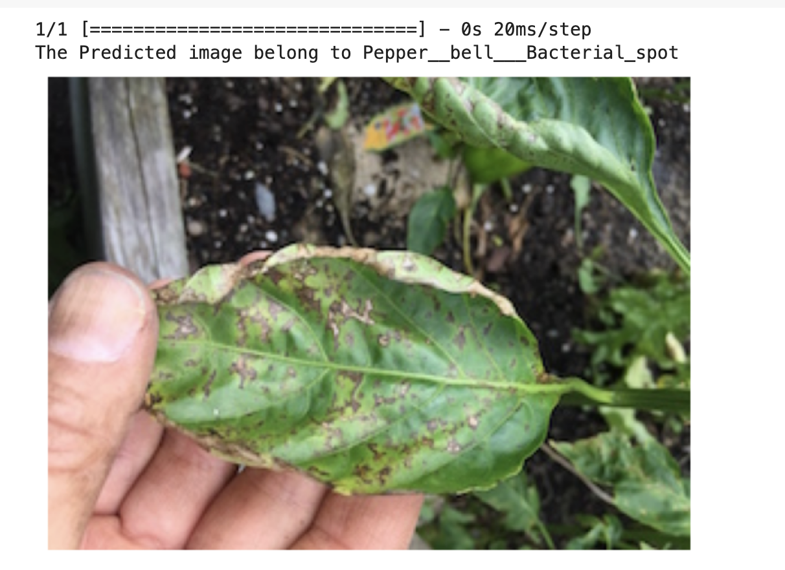

**Fig 6.5 Disease Detection**

In this step the disease is detected for the new input Image



**Fig 6.6 Home Page**

This is the homepage of our website and supports multilingual functionality.

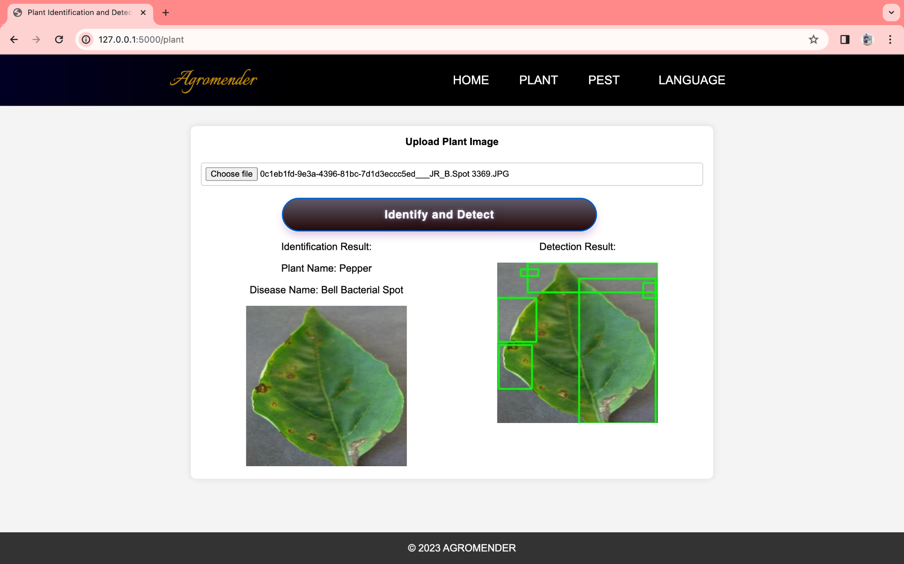

**Fig 6.7 Plant Identification and Detection**

This is the Plant Identification and Disease Detection Page.

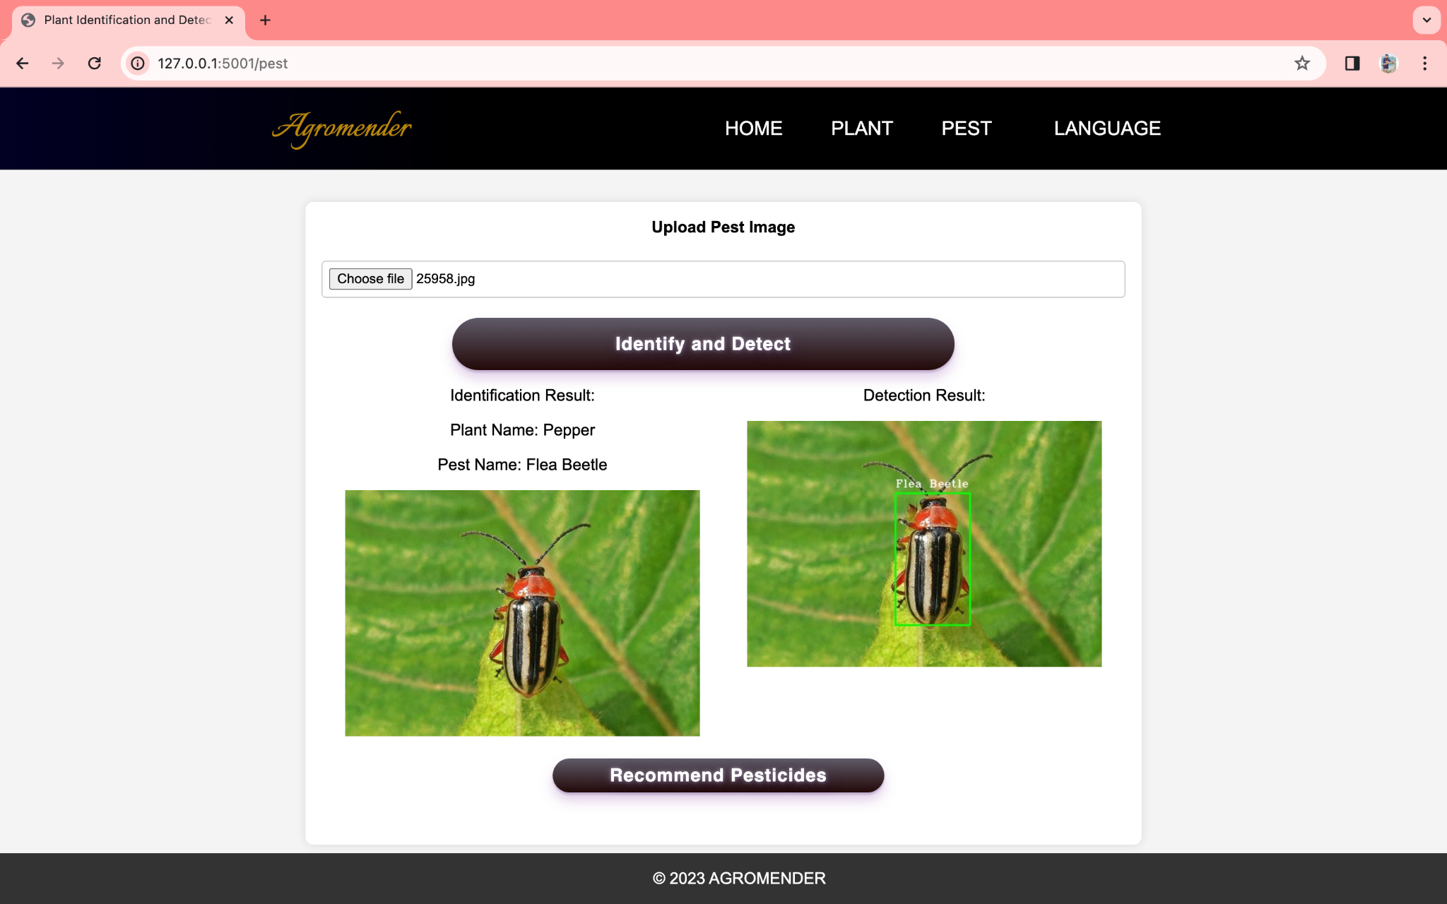

**Fig 6.8 Pest Identification and Detection**

This is the Pest Identification and Detection Page .

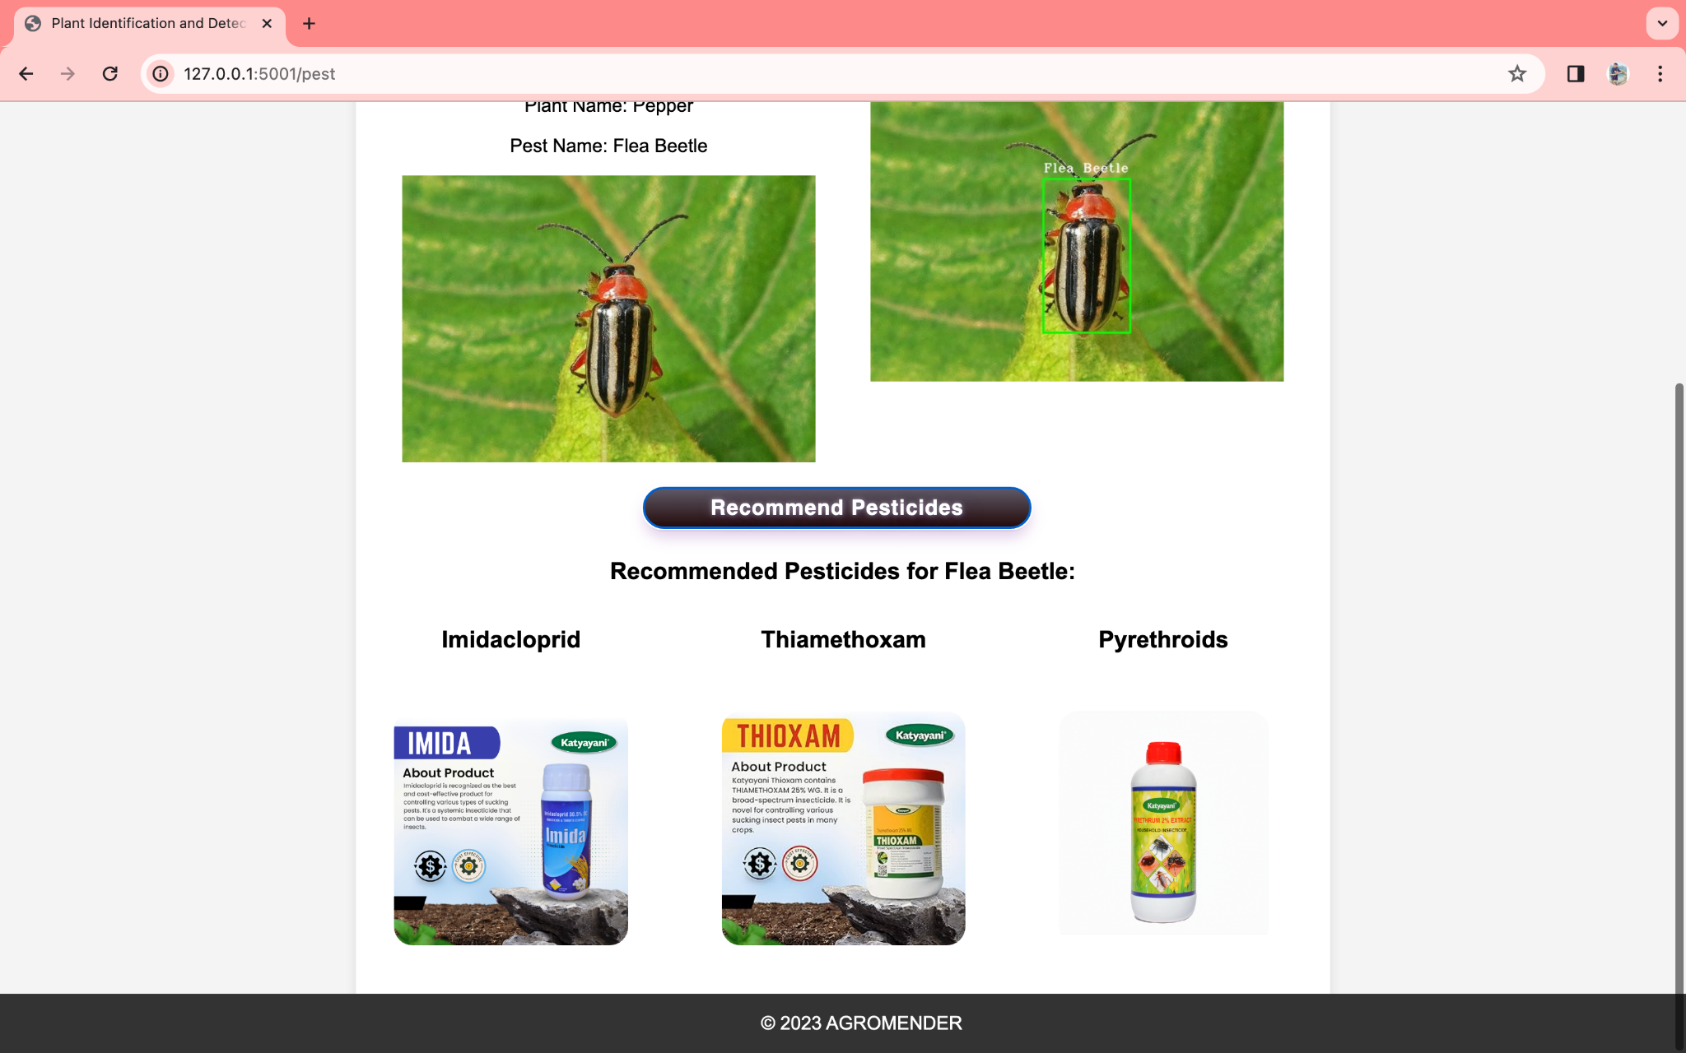

**Fig 6.9 Pesticides Recommendation**

This is the Pesticides Recommendation Page .

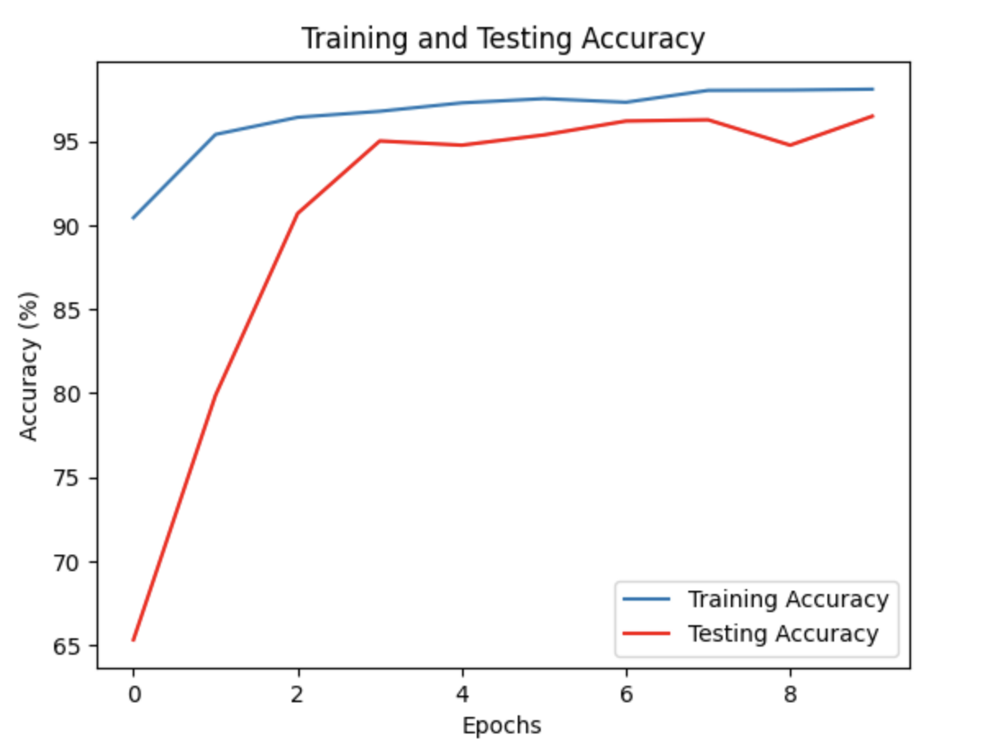

**Fig 6.10 Training and Testing accuracy for plant**

Graph shows the variation in training and testing accuracy for Plant disease detection.

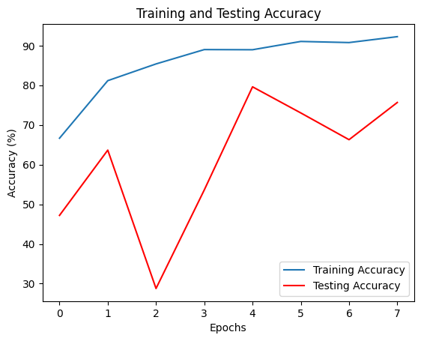

**Fig 6.11 Training and Testing accuracy for Pest**

Graph shows the variation in training and testing accuracy for Pest identification.

**Table 3.1.Comparison of accuracies between various models of plant disease detection**

| **Sr.No.** | **Model Name** | **Accuracy** |
| --- | --- | --- |
| 1 | VGG16 | 73.79 |
| 2 | ResNet50 | 60.56 |
| 3 | InceptionV3 | 70.85 |
| 4 | MobileNet | 93.46 |

**Table 3.2.Comparison of accuracies between various models of pest identification**

| **Sr.No.** | **Model Name** | **Accuracy** |
| --- | --- | --- |
| 1 | VGG16 | 73.66 |
| 2 | ResNet50 | 35.94 |
| 3 | ResNeXt50 | 27.46 |
| 4 | InceptionV3 | 87.5 |
| 5 | MobileNet | 55.13 |
| 6 | DenseNet121 | 91.52 |

##### **CONCLUSION**

In conclusion, the "Plant Disease Detection and Pest identification" project presents an innovative and impactful solution that leverages advanced technologies to revolutionize the way plant health is managed in agriculture. By harnessing the power of machine learning, image classification, and real-time data processing, this project addresses the critical challenges faced by farmers in identifying and mitigating plant diseases and pest infestations. The proposed solution offers a user-friendly interface that bridges the gap between modern technology and the agricultural sector. Farmers, regardless of their technical expertise, can easily capture and upload images of their crops, receiving immediate insights into the health status of their plants. This real-time analysis empowers them to make informed decisions and take timely actions, minimizing crop losses and maximizing yields.

##### **REFERENCES**

[1]Y. Liu, G. Gao and Z. Zhang, "Crop Disease Recognition Based on Modified Light-Weight CNN With Attention Mechanism," in IEEE Access, vol. 10, pp. 112066-112075, 2022, doi: 10.1109/ACCESS.2022.3216285. ( [LINK](https://drive.google.com/file/d/1pHhb0ZUpthyVJxr9bC5tIHs4YOTguzxB/view?usp=drive_link))

[2]Gupta, S., Chopade, A., Jain, N., & Bhonde, A. (2022). Farmer's Assistant: A Machine Learning Based Application for Agricultural Solutions. *arXiv preprint arXiv:2204.11340*.([Link](https://drive.google.com/file/d/1-sIkt9RezGnRqHyiX00huL64m9ku0Yyb/view?usp=sharing))

[3]L. Li, S. Zhang and B. Wang, "Plant Disease Detection and Classification by Deep Learning—A Review," in *IEEE Access*, vol. 9, pp. 56683-56698, 2021, doi: 10.1109/ACCESS.2021.3069646. ([Link](https://drive.google.com/file/d/1wXaNzpQc-Ph6U4eWUiIGpz3yWgqYzbra/view?usp=drive_link))

[4]Thenmozhi Kasinathan, Dakshayani Singaraju, Srinivasulu Reddy Uyyala, “Insect classification and detection in field crops using modern machine learning techniques” ,Volume 8, Issue 3, September 2021. ([Link](https://drive.google.com/file/d/1yAMb_ia8bJ7Ikn-wHpNulQlm82Az3bbD/view?usp=drive_link))

[5] Jajoo, P., Jain, M.K., Jangir, S. (2022). A Case Study on Machine Learning Techniques for Plant Disease Identification. In: Balas, V.E., Sinha, G.R., Agarwal, B., Sharma, T.K., Dadheech, P., Mahrishi, M. (eds) Emerging Technologies in Computer Engineering: Cognitive Computing and Intelligent IoT. ICETCE 2022. Communications in Computer and Information Science, vol 1591. Springer, Cham([LINK](https://drive.google.com/file/d/1SpFLCTpTzrYitzz-wwX_7ow_u1PuwTBX/view?usp=drive_link)).

[6]A. Kumar, S. Sarkar and C. Pradhan, "Recommendation Systemfor Crop Identification and Pest Control Technique in Agriculture," 2019 International Conference on Communication and Signal Processing (ICCSP), Chennai, India, 2019, pp. 0185-0189, doi: 10.1109/ICCSP.2019.8698099. ([LINK](https://drive.google.com/file/d/1-iXW594DUfGPZ0yEIiVWpcKaN_LX2zWv/view?usp=drive_link))  
[7]Domingues, T.; Brandão, T.; Ferreira, J.C. Machine Learning for Detection and Prediction of Crop Diseases and Pests: A Comprehensive Survey. *Agriculture* **2022**, *12*, 1350. ([LINK](https://drive.google.com/file/d/1NHD0Xmc19oORVTulM80sjslwXR1OkaKy/view?usp=drive_link))